RAJALAKSHMI ENGINEERING COLLEGE
An Autonomous Institution, Affiliated to Anna University
Rajalakshmi Nagar, Thandalam – 602 105

WEB TECHNOLOGY AND MOBILE APPLICATION
Experiment – 03
2025-26

By
NIJANTHAN V
B-TECH AI&DS
2116241801185

Expt.NO: 03 DATE:
Write a Servlet program that prints "Hello, World!" when accessed
through a browser.
AIM:
To write a basic Servlet program that demonstrates the use of Java Servlets by printing "Hello, World!" when accessed through a browser.
ALGORITHM:
1. Input:
- The user makes an HTTP request (usually by entering a URL) through a browser.
2. Servlet Program Flow:
- Create a Servlet Class:
  - Define a Java class that extends the HttpServlet class.
  - Override the doGet() method, which handles HTTP GET requests from the client (browser).
- Handle HTTP Request:
  - In the doGet() method:
    - Get the PrintWriter object to write the response to the browser.
    - Set the response content type to text/html.
    - Write the "Hello, World!" message to the response.
- Compile the Servlet Class:
  - Compile the Java Servlet file using the javac command to generate a .class file.
- Deploy the Servlet:
  - Place the compiled servlet class file in the appropriate directory of the web application (typically in the /WEB-INF/classes folder).
  - Configure the servlet in the web.xml file of the web application or use annotations.
- Access the Servlet via Browser:
  - Start the Apache Tomcat or another servlet container.
  - Access the servlet by entering the appropriate URL (e.g., http://localhost:8080/your-webapp/hello).

CODE:

package com.demo;

import java.io.*;
import jakarta.servlet.*;
import jakarta.servlet.http.*;
import jakarta.servlet.annotation.WebServlet;

@WebServlet("/hello")
public class Hello extends HttpServlet {

protected void doGet(HttpServletRequest request, HttpServletResponse response)
throws ServletException, IOException {

response.setContentType("text/html");
PrintWriter out = response.getWriter();
out.println("<h1>Hello, World!</h1>");
out.close();
}
}

OUTPUT:

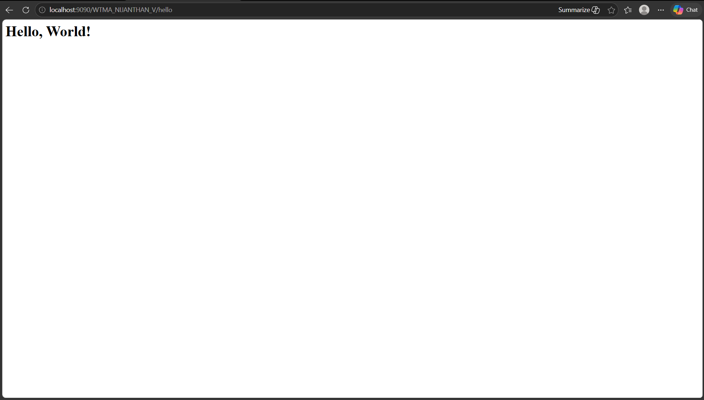

RESULT:
The browser will display the message "Hello, World!" returned by the Servlet.

